# Overview

Upon completion of this chapter, the participant will be able to:

* Discuss the similarities and differences between views in PWA and Project Pro.
* Apply enterprise views in PWA and Project Pro.
* Use the PWA display options to tailor multiple types of views.
* Use Project Pro quick click options and dual pane options to tailor multiple types of views.
* Configure the appropriate level of detail in a timescale portion of a view.
* Differentiate between and apply sorting, grouping and filtering.
* Show and hide columns of information to personalize a view.
* Explain the advantage of changing tables within a view in Project Pro.
* Properly format global text and bar options in Project Pro.
* List limitations to personalizing enterprise views and enterprise fields in PWA and Project Pro.

# Working with Views in PWA and Project Pro

Both PWA and Project Pro have numerous views that you can select from and customize to display the information you need. Since the information you are viewing is coming from Project Server or Project Online, you are working with real-time, up-to-date information. Many organizations use views as a reporting mechanism.

## Working with Display Options in PWA

On many pages in PWA (such as the Project Center page and the Project Details Schedule page) there are some common display options for showing desired information when viewing the timescale (located on the right side of the display). In this topic, we will differentiate between the different zoom options and their purpose in controlling the display. These options are available even if you change the view for a specific page.

There are three different options available:

* Zoom In – shows more detail on the timescale. For example, moving from weeks to days. This option may be clicked several times to get the level of detail desired.
* Zoom Out – shows less detail on the timescale. For example, moving from weeks to months. This option may be clicked several times to get the level of detail desired.
* Scroll to Task/Project – displays the Gantt bar for the selected row (task or project).

To Change the Display Options:

1. In the Quick Launch menu, click Projects.
2. On the Project Center page, Zoom group, click Zoom In or Zoom Out to adjust the timescale level of detail.

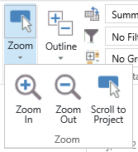

1. Zoom options on Project Center Page [Zoom options on Project Center Page Small.tif]
2. On the Project Center page, click the row selector for any row and in the Zoom group, click Scroll to Project to bring the Gantt bar into view in the timescale.

### Working with Show/Hide Options

On various PWA pages, such as the Project Center page and the My Tasks page, there are show/hide options. The choices within the Show/Hide group vary based on the purpose of the page. Using these options gives flexibility in quickly adding or removing information from the display.

Depending on the amount of information to show or hide, you may have to wait for the page to refresh. You will see “Loading…” as an indicator that you will need to wait.

To Change the Show/Hide Options:

1. In the Quick Launch menu, click Projects.
2. On the Project Center page, Show/Hide group, check the check box Time with Date. Notice in the Start and Finish columns, the time is now displayed.

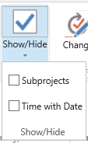

1. Show Hide Options [Show Hide Options Small.tif]
2. Uncheck the check box Time with Date and notice the time is now hidden.

Each checkbox (such as Time and Date, or Subprojects) is an independent Show/Hide option.

### Working with Data Options

Data options grant the ability to control the view of a particular PWA page and how the information in that view is organized or defined. Refer to the following for examples:

* Outline – use this to change the level of outline details displayed such as summary and subtasks.
* View – both default views and those defined by the organization are available in this dropdown list. A view is simply a name given to a visual collection of information which may include things such as columns/fields, formatting, and a timescale.
* Filter – hides or shows rows based on a condition.
* Group – organizes/categorizes information by a field.

To change the data options:

1. In the Quick Launch menu, click Projects.
2. On the Project Center page, Data group, Group By: list, click Owner. Notice the projects are grouped by each owner.

## Working with Views in PWA

A view is a set of fields, filters, groups, data sort, etc., that PWA uses when displaying project or resource information. Views represent information in the form of live and interactive reports when accessing project or resource data. The Project Server database contains many default views that allow project stakeholders to analyze information in a variety of ways.

Views also enable project managers to communicate critical information about their projects to other individuals and groups in the organization.

The default views can be accessed based on the permissions a project stakeholder is assigned in PWA.

### Overview of View Types

The views in PWA are categorized based on the type of information they contain and each view serves a specific purpose. For example, some views enable team members to only see information about their tasks, while other views enable project managers to keep track of their projects. Additional views allow resource managers to determine resource availability and evaluate assignments across projects.

The default categories of views that contain project and resource data which are relevant in this book are: Project, Project Center, Resource Assignments, Resource Center, My Work, Resource Plans, Team Tasks, Team Builder and Timesheet.

Experienced users of PWA often call the Project category Project Details to further differentiate it from the Project Center category. The Project Center category only has a summary line of information for each project.

### Project Center Views

The Project Center provides a convenient way for project stakeholders to view summary information about projects that have been published to the Project Server database. In Project terms, it displays the Project Summary Task (row 0) for each project. You can see summary information about multiple projects and also review detailed information about specific projects.

The Project Center page displays indicators about project-related information. For example, document or risk indicators are displayed when documents or risks are linked to a project. The view can also be used to filter, group and sort projects. Project Center contains many default views which can be modified. New, custom views can be created.

To apply a view in the Project Center:

1. On the Quick Launch menu, click Projects.
2. In the Projects tab, Data group, click the View dropdown arrow and select the desired view.

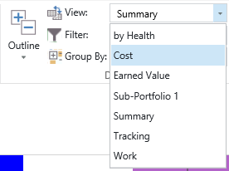

1. Data Group in Project Center Ribbon [Data Group in Project Center Ribbon Large.tif]

The chart portion of the Gantt chart view displays each project as a summary Gantt bar. Different fields are displayed in the sheet portion of the view, depending on the view that you choose.

### Project Views

PWA provides a complete overview of all the projects in the Project Center view and also allows you to drill down to individual projects using the Project views. The Project views display detailed task level information for individual projects. This category contains the maximum number of views that provide cost, tracking, summary, work, earned value and leveling information for each task within a project.

It is important to note that views in Project Pro are not directly mapped to the Project Views in PWA. For example, PWA Project Views do not have the Calendar or the Network Diagram views.

The list below provides details of views in the Project Detail Pages – Schedule:

1. Views in the Project Detail Pages – Schedule

|  |  |
| --- | --- |
| View Name | List of Fields Included |
| Assignments Cost | Task Name, Resource Name, Cost, Baseline Cost, Cost Variance, Actual Cost, Remaining Cost, Start, Finish |
| Assignments Detail | Task Name, Resource Name, Delay, Work, Start, Finish |
| Assignments Earned Value | Task Name, Resource Name, BCWS, BCWP, ACWP, SV, CV, Cost, Baseline Cost, VAC, Start, Finish |
| Assignments Summary | Task Name, Resource Name, Assignment Owner, Work, Start, Finish, % Work Complete |
| Assignments Tracking | Task Name, Resource Name, Assignment Owner, Start, Finish, Actual Start, Actual Finish, Baseline Start, Baseline Finish, % Work Complete, Actual Cost, Actual Work |
| Assignments Work | Task Name, Resource Name, Work, Baseline Work, Work Variance, Actual Work, Remaining Work, % Work Complete, Start, Finish |
| Resources Cost | Unique ID, Resource Name, Cost, Baseline Cost, Cost Variance, Actual Cost, Remaining Cost, Start, Finish |
| Resources Earned Value | Unique ID, Resource Name, BCWS, BCWP, ACWP, SV, CV, Cost, Baseline Cost, VAC, Start, Finish |
| Resources Summary | Unique ID, Resource Name, Group, Max Units, Peak, Standard Rate, Overtime Rate, Cost, Work, Start, Finish |
| Resources Work | Unique ID, Resource Name, % Work Complete, Work, Overtime Work, Baseline Work, Work Variance, Actual Work, Remaining Work, Start, Finish |
| Select Tasks for Timeline | ID, Task Name, Start, Finish |
| Tasks Cost | ID, Mode, Task Name, Fixed Cost, Fixed Cost Accrual, Cost, Baseline Cost, Cost Variance, Actual Cost, Remaining Cost, Start, Finish, Resource Names |
| Tasks Detail | ID, Mode, Task Name, Leveling Delay, Duration, Start, Finish, Resource Names |
| Tasks Earned Value | ID, Mode, Task Name, BCWS, BCWP, ACWP, SV, CV, Cost, Baseline Cost, VAC, Start, Finish, Resource Names |
| Tasks Leveling | ID, Mode, Task Name, Leveling Delay, Duration, Start, Finish, Preleveled Start, Preleveled Finish, Early Start, Resource Names |
| Tasks Schedule | ID, Mode, Task Name, Start, Finish, Late Start, Late Finish, Free Slack, Total Slack, Resource Names |
| Tasks Summary | ID, Mode, Task Name, Duration, Start, Finish, % Complete, Work, Resource Names |
| Tasks Top-Level | ID, Mode, Task Name, Duration, Start, Finish, % Complete, Work, Resource Names |
| Tasks Tracking | ID, Mode, Task Name, Start, Finish, Actual Start, Actual Finish, Baseline Start, Baseline Finish, % Complete, Duration, Actual Duration, Remaining Duration, Actual Cost, Actual Work, Resource Names |
| Tasks Work | ID, Mode, Task Name, Work, Baseline Work, Work Variance, Actual Work, Remaining Work, % Work Complete, Start, Finish, Resource Names |

To change views in the Project Detail Pages – Schedule page:

1. In the Quick Launch menu, click Projects.
2. Click on the Project Name.
3. On the Schedule page, in the Task tab, Data group, View dropdown, select the desired view.

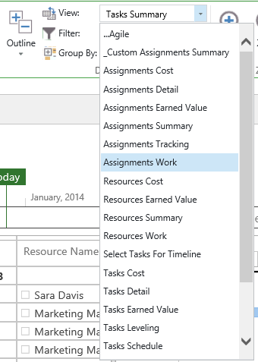

1. Data Group in Project Details Ribbon [Data Group in Project Details Ribbon Large.tif]

### Resource Assignment Views

Resource Assignment views display information about the projects and assignment progress associated with each resource. These views are very useful for resource managers. Resource Assignment views allow resource managers to see the progress resources have reported and plan for future assignments based on currently assigned work.

The Resource Assignment views give a list of tasks grouped by resource name and then by project name. It resembles the Resource Usage view in Project Pro. You can also set a date range to view the assignments and display data in the form of a Gantt chart or Timephased format.

To view resource information in the Resource Assignments view:

1. In the Quick Launch menu, click Resources.
2. Select the checkbox for the desired resources.
3. In the Resource tab, Navigate group, click Resource Assignments.

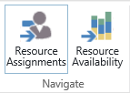

1. Navigate Group in Resource Center Ribbon [Navigate Group in Resource Center Ribbon.tif]

### Resource Center Views

The Resource Center provides summary information of all resources that are part of the Enterprise Resource Pool and are published to the Project Server database. A list of useful default views is available to support resource management in Project Server.

In the Resources tab, Data group, there is a dropdown menu next to View: that contain these popular views:

* All Resources – includes all resources grouped by resource type (i.e., work, cost and material). In addition, the view also displays a large set of useful resource information.
* Cost Resources – displays only cost resources and their associated resource information.
* Material Resources – displays only material resources and their associated resource information.
* Resources by Team – displays resource information for resources associated with team assignment pools.
* Work Resources – displays only work resources and their associated resource information.

To apply a view in the Resource Center:

1. In the Quick Launch menu, click Resources.
2. In the Resources tab, Data group, click the dropdown arrow next to View: and select the desired view.

### Task Views

Team members can gain insight into the plan for the projects they are working on and details about the tasks they have been assigned by using the views available when using the Tasks page.

The Tasks page opens My Assignments view by default. My Assignments view allows team members to fill in and update progress information for each task. You can change the layout of this view to Gantt Chart, Timephased Data or Sheet format.

A different view is available when a team member clicks on a task. That view is called Details.

To apply the My Assignments view:

1. In the Quick Launch menu, click Tasks.
2. By default, the My Assignments view will open. To change the view, in the Task tab, Data group, click the dropdown arrow next to View: and choose the desired view.

By default, there will be only one view listed in the dropdown menu of the Tasks page unless new custom views have been created.

### Resource Plan View

Using the Resource Plan view, project managers can create resource plans for their projects. Using resource plans, a high level resource requirement for a project can be prepared during the project initiation phase. It is not required to assign resources to any task in the Resource Plan view.

The Resource Plan view is helpful when you need to advise the project managers, resource managers and executives of upcoming work, but you do not know the specific tasks or resources that will be assigned to the project plan. This view shows a grid of resource names and timephased work where entries can be made to block a resource for corresponding hours allocated.

To access a Resource Plan view:

1. In the Quick Launch menu, click Projects.
2. On the Project Center page, click the row selector next to the desired project.

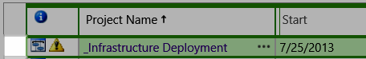

1. Project Center Row Selector [Project Center Row Selector.tif]
2. In the Projects tab, Navigate group, click Resource Plan.
3. To change the view, in the Plan tab, Display group, click the dropdown arrow next to View: and choose the desired view.

By default, there will be only one view listed in the dropdown menu of the Resource Plan page unless new custom views have been created.

### Team Tasks View

Team members can use the Team Tasks view to review the tasks to which their team is assigned as a resource. An example of teams are: Team Marketing, and Team IT. The project manager can assign a task to team “Marketing,” and the individuals who belong to that team can pick from the list of team tasks and assign themselves that task.

The Team Task view will only show tasks if the Team Feature has been configured by the Project administrator.

To access the Team Tasks view:

1. In the Quick Launch menu, click Tasks.
2. On the Task page, in the Tasks tab, Tasks group, click the Add Row dropdown arrow and choose Add Team Tasks.
3. On the Team Task page, in the Tasks tab, Data group, click the dropdown arrow next to View: and choose the desired view.

By default, there will be only one view listed in the dropdown menu of the Team Task page unless new custom views have been created.

### Team Builder View

The Team Builder view provides resource managers and project managers access to the preferred list of resources to be assigned to a project or used in the resource plan. The default list of views available for the Team Builder is similar to the view list available in the Resource Center.

To access a Team Builder view:

1. In the Quick Launch menu, click Projects.
2. Select a project for which you would like to build a team of resources.
3. In the Projects tab, Navigate group, click Build Team.
4. On the Build Team page, Team tab, Data group, click the dropdown arrow next to View: and select the desired view.

### Timesheet View

The Timesheet view allows team members to fill in timesheet information for project and non-project work. The Timesheet view is only available to team members when the project administrator configures the timesheet periods.

To access the Timesheet view:

1. In the Quick Launch menu, click Timesheets.
2. To change the view, in the Options tab, Data group, click the dropdown arrow next to View: and choose the desired view.

Views can be customized as needed. Typically only the administrator has the ability to customize views. In contrast to Project Pro, the ability to insert fields of information in PWA is restricted to a pre-defined list of fields for each view. This provides additional security in PWA and prevents individuals from seeing confidential information.

## Working with Groups and Filters

The Filter and Group options help you to focus on specific aspects of projects, tasks and resources by revealing only desired data, instead of all the project data. This surfaces the necessary information for quick analysis and management. Examples include displaying projects that are at 100% complete or grouping resources by similar skillset.

### Overview of Grouping and Filtering Options

Grouping allows the user to display data in associations of a common trait. For example, a user can group tasks by Critical and Non-Critical status, or % Complete status, or group tasks by assigned resource.

Applying a filter allows you to specify criteria that will determine what projects, resources or tasks should be displayed in a given view. Any information that does not correspond to the criteria will not be displayed.

To apply a filter to a view:

1. Navigate to the desired view.
2. Using the appropriate tab (e.g., Projects or Resources), Data group, click the dropdown arrow next to Filter: and choose the desired filter.

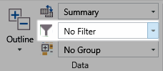

1. Filters and Groups [Filters and Groups Shaded.tif]

To apply an auto filter option:

1. Hover your mouse over the desired column name and click the dropdown arrow.
2. Choose from the pre-defined list of auto-filters.

PWA also supports auto-filter, which is similar to a regular filter, but can be applied directly using the column headings without invoking the options in the ribbon.

By applying a group to a view in PWA, all similar information will be arranged by some common characteristic.



1. Filters and Groups [Filters and Groups Shaded.tif]

To apply a group to a view:

1. Navigate to the desired view.
2. Using the appropriate tab (e.g., Projects or Resources), Data group, click the dropdown arrow next to Group by: and choose the desired field to group the view.

Clearing filters and groups will be discussed in a later topic. Filters and groups are maintained until you change them even as you navigate through other PWA pages.

### Creating Custom Groups and Filters

PWA offers a variety of default auto-filter and group options that help you view specific information for projects, resources and tasks. If the pre-defined filters and groups do not meet your needs, custom filters and groups can be applied.

To create a custom filter:

1. Navigate to the desired view.
2. Using the appropriate tab (e.g., Projects or Resources), Data group, click the dropdown arrow next to Filter: and choose Custom Filter.

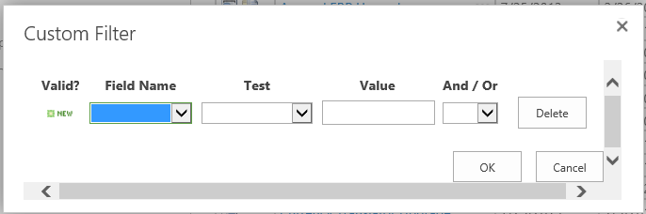

1. Custom Filter [Custom Filter.tif]
2. In the Custom Filter dialog box, select a field in the Field Name list and a test in the Test list,
3. Type a value to test for in the Value box. You can set a range of values by typing two values separated by a comma (,) in the Value box.
4. If the filter contains more than one criterion row, select an operator in the And/Or column to start a new row.
5. Click OK.

Once the filter criteria are validated, a checkmark will appear in the Valid? column.

To create a custom group:

1. Navigate to the desired view.
2. Using the appropriate tab (e.g., Projects or Resources), Data group, click the dropdown arrow next to Group by: and choose Custom Group.
3. In the Group Fields dialog box, in the Group By dropdown list select the desired field.
4. To enable multiple levels of grouping, use the Then By dropdown lists and select the desired field for a second or third level grouping.
5. Click OK.

### Clearing Custom Groups and Filters

Once a custom filter or a custom group option has been applied to a view, it is very easy to clear these options and reset the view.

To clear a custom filter:

1. Navigate to the desired view.
2. Using the appropriate tab (e.g., Projects or Resources), Data group, click the dropdown arrow next to Filter: and choose No Filter.

To clear an auto filter:

1. Hover your mouse over the desired column name.
2. Click the dropdown arrow and choose Clear Filter.

To clear a custom group:

1. Navigate to the desired view.
2. Using the appropriate tab (e.g., Projects or Resources), Data group, click the dropdown arrow next to Group By: and choose No Group.

Warning – Any view, filter, grouping, or display options that were implemented by the user to access a view are automatically saved in PWA for that specific user. You should not expect other users to have the exact same configuration of a view that you have.

## Sorting in a PWA View

PWA initially arranges rows of information according to ascending ID number. The ID number is usually located in the far left column of the displayed view. If the ID column is not visible, it is most likely hidden. If available, insert the ID column to make it visible again.

As a reminder, the administrator restricts the columns in PWA to a pre-defined list for each view.

To make it easier to work with your projects, tasks, and resources, you can temporarily (or permanently) rearrange them. For example, you can rearrange the order of tasks based on a column such as, start date, finish date, priority, cost, or ID. You can also sort resources. By default, resources are arranged in ascending order based on the ID number, but you can sort resources by cost or name.

To sort activities:

1. Click the dropdown arrow on the field column heading.
2. Select the desired sorting option from the list.

You can click the name of a column heading to quickly sort by that column. It will switch from ascending to descending each time you click on the heading.

A pre-defined sort can be achieved through a custom view created by your administrator.

## Working with Quick Click Options in Project Pro

Project Pro has a number of similarities with PWA when it comes to manipulating views. Throughout the remainder of this module, we will be focusing on the techniques to use those options in Project Pro. We will also cover additional features that are available to support the advanced scheduler.

Quick click options in Project Pro look the same as checkboxes in PWA. Project Pro provides quick clicks to apply a feature immediately instead of proceeding through a list of steps in a dialog box or wizard which would take more time to apply.

To use a quick click option:

1. Navigate to Project Professional
2. In the File tab, click Open.
3. Click the desired project and click Open.
4. In the Format tab, in the Bar Styles group or the Show/Hide group, click the desired checkbox.

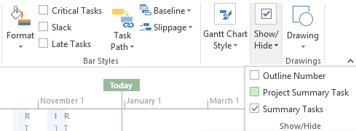

1. Format tab Quick Click Options in Project Pro [Format tab Quick Click Options in Pro.tif]

## Working with Timescale Options in Project Pro

Numerous views in Project Pro have a timescale portion on the right side of the screen. Gantt Chart and Resource Usage view are examples. For these views, you can tailor the timescale to show the level of detail you desire. Project Pro has the advantage of offering more timescale and zooming shortcuts than PWA.

To use a timescale option:

1. In the Tasktab, in the View group, select the desired view from the Gantt Chart dropdown list.
2. In the View tab, in the Zoom group use one of the following shortcuts:

* In the Timescale: dropdown list, select an option from the list to quickly zoom to a week view, month view, etc.
* In the Zoom dropdown list, choose Zoom In, Zoom Out or Custom Zoom to quickly adjust the timescale incrementally.
* Click Entire Project to zoom the information so it fits within the available timescale screen spaces.
* Highlight a group of tasks and click Selected Tasks to zoom the information for those tasks only so the selected group of tasks fits within the available timescale screen space.

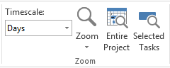

1. Zoom Group in View Tap of Ribbon [Zoom Group in View Tap of Ribbon Large.tif]

Zoom In and Zoom Out shortcuts are also available in the Status Bar in the lower right corner of your screen.

In Gantt Chart view, zooming Entire Project is a useful option to apply just before printing.

## Working with Views in Project Pro

A view in Project Pro consists of many elements which can be tailored in a lot more detail in Project Pro than in PWA. In this section and the remaining sections of this module, we will be discussing changing views and changing the elements within those views based on personal preferences.

Enterprise views and related elements are configured by your administrator. Normally an enterprise view has a prefix of Enterprise or something unique to your organization such as company initials. You will receive an error if you attempt to change one of these items. Please consult with your administrator for information about identifying enterprise views.

### Exploring Tables

Instead of Project giving you a long list of columns that you need to scroll through in views, you are presented with a subset of those columns. These columns have been grouped by subject area into what Project calls Tables.

You can show/hide columns within a table or you can change to another table. The available options for tables change based on the type of view you are in (Task view, Resource view, or Assignment view).

### Show/Hiding Columns

Project is a database application. Unlike Excel, you only have the option to show or hide columns but never add or permanently delete a column. That is because each column in Project is tied to a field in the SQL server database and the number of fields have been predetermined for you.

Some of the columns available to you are set aside for custom information (e.g. Text 1- Text 10) that you can use as needed if Project does not already have a column for your desired purpose. Refer to MPwMP2013-Advanced for information about customizing Project Pro columns.

Your administrator can create new enterprise columns if required.

As a project manager, you can only edit columns provided by Microsoft or your administrator for that purpose. Recommendations on what columns to use for your projects would be best obtained through your organization as each environment is uniquely configured.

To hide a column:

1. Right-click the column heading and click Hide Column.

To show a column:

1. Right-click the column heading and click Insert Column.
2. Click the desired column name.

You can type the first few letters of the column name to quickly filter the list.

You can also use the shortcut Add New Column on the far right side of the table.

### Changing Tables

Tables automatically change based on the view you are in. You have the option to switch to another table without changing views.

To change tables:

1. In the View tab, in the Data group, in the Tables dropdown, click the desired table.

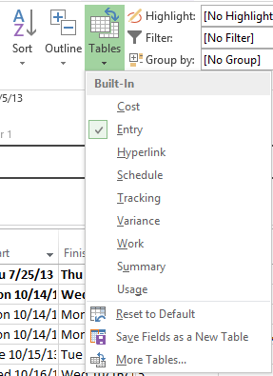

1. Changing Tables Using the Data Group in Project Pro [Changing Tables in Project Pro Large.tif]

Warning – If you save your schedule with an alternate table applied to a view, this will become the new default for that view. It may be helpful to jot down the original name of the table associated with that view before you make changes.

### Changing Views

One of the valuable features in Project Pro is the ability to analyze information quickly through the use of views. Views are configured to show one of these groupings of information in the database:

* Task only information
* Resource only information
* Combination task and resource information typically illustrating assignments

To change views:

1. In the Task tab, in the View group, in the Gantt Chart dropdown, click the desired view.

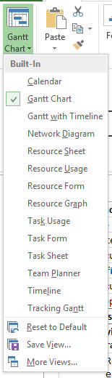

1. Changing Views Using the Ribbon in Project Pro [Changing Views Using the Ribbon in Project Pro.tif]

Right-clicking on the name of the view in the View Bar is another way to quickly change views.

### Using Dual Pane Views

With all the fields of information available in Project, scrolling left and right is not always the most efficient approach to display hidden columns or information available from the Gantt bars. Instead, you should use a dual pane view to show information for the selected task or resource in the upper pane and additional, related information in the lower pane. For example, on a selected task, you might want to see the Task Start and Finish date in the upper pane, but in the lower pane show the Predecessors and Successors.

Information in the lower pane is dependent on what is selected in the upper pane. You can only see details for one item at a time in the lower pane.

To turn on a dual pane view:

1. In the View tab, in the Split View group, check the Details checkbox.
2. In the Details dropdown list, choose the desired lower pane view.

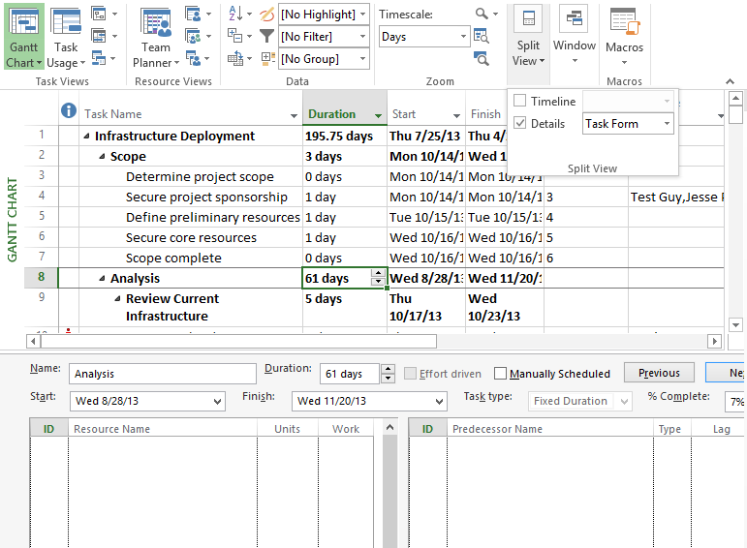

1. Dual Pane View in Project Pro [Dual Pane View in Project Pro.tif]

## Grouping and Filtering in Project Pro

As a reminder, grouping allows the user to display data in associations of a common trait. For example, a user can group tasks by Critical and Non-Critical status, or % Complete status, or group tasks by assigned resource.

Applying a filter allows you to specify criteria that will determine what projects, resources or tasks should be displayed in a given view. Any information that does not correspond to the criteria will not be displayed. Project Pro provides the additional option of a highlight filter which shows all information but highlights the tasks which meet that condition.

Project Pro supports auto-filtering which is turned on by default. There are specific unique filters available through this feature that can be useful to the scheduler or project manager. The available unique filters vary by column. An example from the Start column is you can show tasks starting next week. An example from the Duration column is you can show tasks longer than 1 week.

To apply a filter, highlight filter, or group from the Ribbon:

1. In the View tab, in the Data group, choose the appropriate option from the Highlight:, Filter: or Group by: dropdown lists.
2. Choose [No Highlight], [No Filter]**,** or [No Group] to turn off these options.

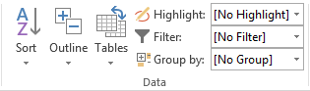

1. Data Group in Project Pro [Data Group in Project Pro Large.tif]

To apply an auto filter from the table:

1. Click the dropdown arrow next to a column heading name and do one of the following:

* Filter items by checking or unchecking boxes next to the information currently in the column.
* Click Filters in the menu to display the submenu of pre-defined filters. Click the desired option.

1. Click Clear Filter to cancel the filter.

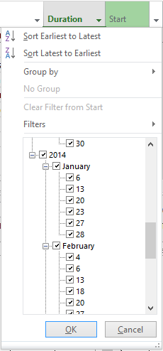

1. Autofiltering and Using Pre-Defined Filters in a Column in Project Pro [Pre-Defined Filters in a Column in Project Pro.tif]

Using columns to filter information often filters other columns you didn’t intend. As a shortcut, press F3 to globally cancel all filtering and return to showing all information.

## Sorting in a Project Pro View

You can sort information in a table in any view in Project Pro.

To sort information:

1. Click the dropdown arrow next to a column heading name and choose the appropriate sort option: Sort Ascending or Sort Descending.
2. To return to the default state of the view, sort by ID number. In the View tab, in the Data group, in the Sort dropdown list, click by ID.

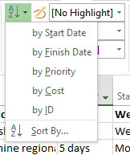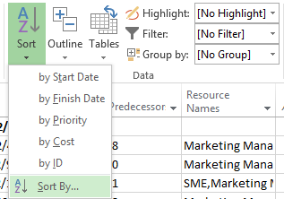

1. Sorting Information Using the Data Group in Project Pro [ Using the Sort Drop Down in Project Pro Small.tif OR Using the Sort Drop Down in Project Pro Large.tif]

## Formatting Views in Project Pro

Project Pro has Quick Click options to format information (discussed earlier in Working With Quick Click Options in Project Pro). However, you may discover that you need to tailor the formatting in a way not available through a Quick Click. At Advisicon, we recommend two separate formatting approaches: global text formatting and global bar formatting.

To apply global text formatting:

1. In the Task tab, in the View group, click Gantt Chart.
2. In the Format tab, in the Format group, click Text Styles.
3. In the Text Styles dialog box, in the Item to Change dropdown list, click the desired text type.
4. Make the desired font modification and click OK to apply.
5. Repeat as needed for other types of text you want to globally modify.

To apply global bar formatting:

1. In the Task tab, in the View group, click Gantt Chart.
2. In the Format tab, in the Bar Styles group, click the Format dropdown and then click Bar Styles.
3. In the Bar Styles dialog box, select the desired bar in the upper pane and using the lower pane, click either the Text or Bars tab and make the desired changes.
4. Repeat for each bar you with to modify and then click OK to apply.

Warning – Using Format Bar or using any of the Font formatting options on the Task tab of the Ribbon instead of the methods presented above generates an exception to the global style you have previously applied. These items will never respond to future style changes. The only correction that can be applied is to delete these tasks and recreate them.

# Key Points to Remember

* PWA display options are maintained automatically by each user on each view even after navigating away.
* PWA columns that can be displayed are controlled by the administrator.
* Click on a column heading to quickly sort ascending or descending in a PWA view.
* Filtering in PWA hides information and grouping organizes information by a field.
* The autofilter dropdown on column headings in Project Pro provide fast methods to sort, group, filter and use built-in custom filters.
* F3 is a shortcut to remove all filters and show all information.
* Project Pro offers highlight filtering to mark items that meet a specific condition while still showing all items in the list.
* Use zooming options to adjust the timescale to the desired level of detail you need.
* A table is a component of a view in Project Pro and it consists of a subset of the available columns offered in Project Server.
* Enterprise views and enterprise fields are controlled by the administrator in Project Pro.
* In Project Pro, apply global text and global bar formatting to save time and to quickly customize the schedule.